Contact Information
Name:
P. Prajani Mahesha Heenatigala

Contact Phone Number:
0086-113007128596

Contact Email:
prajani15@hotmail.com

Affiliation:
Institute of Hydrobiology, Chinese Academy of Sciences

Manuscript Information (if applicable)
Title:

Journal:

Authors:

Species Identification Information
Name of Species:
Wolffia globosa

Morphological Classification (if applicable):

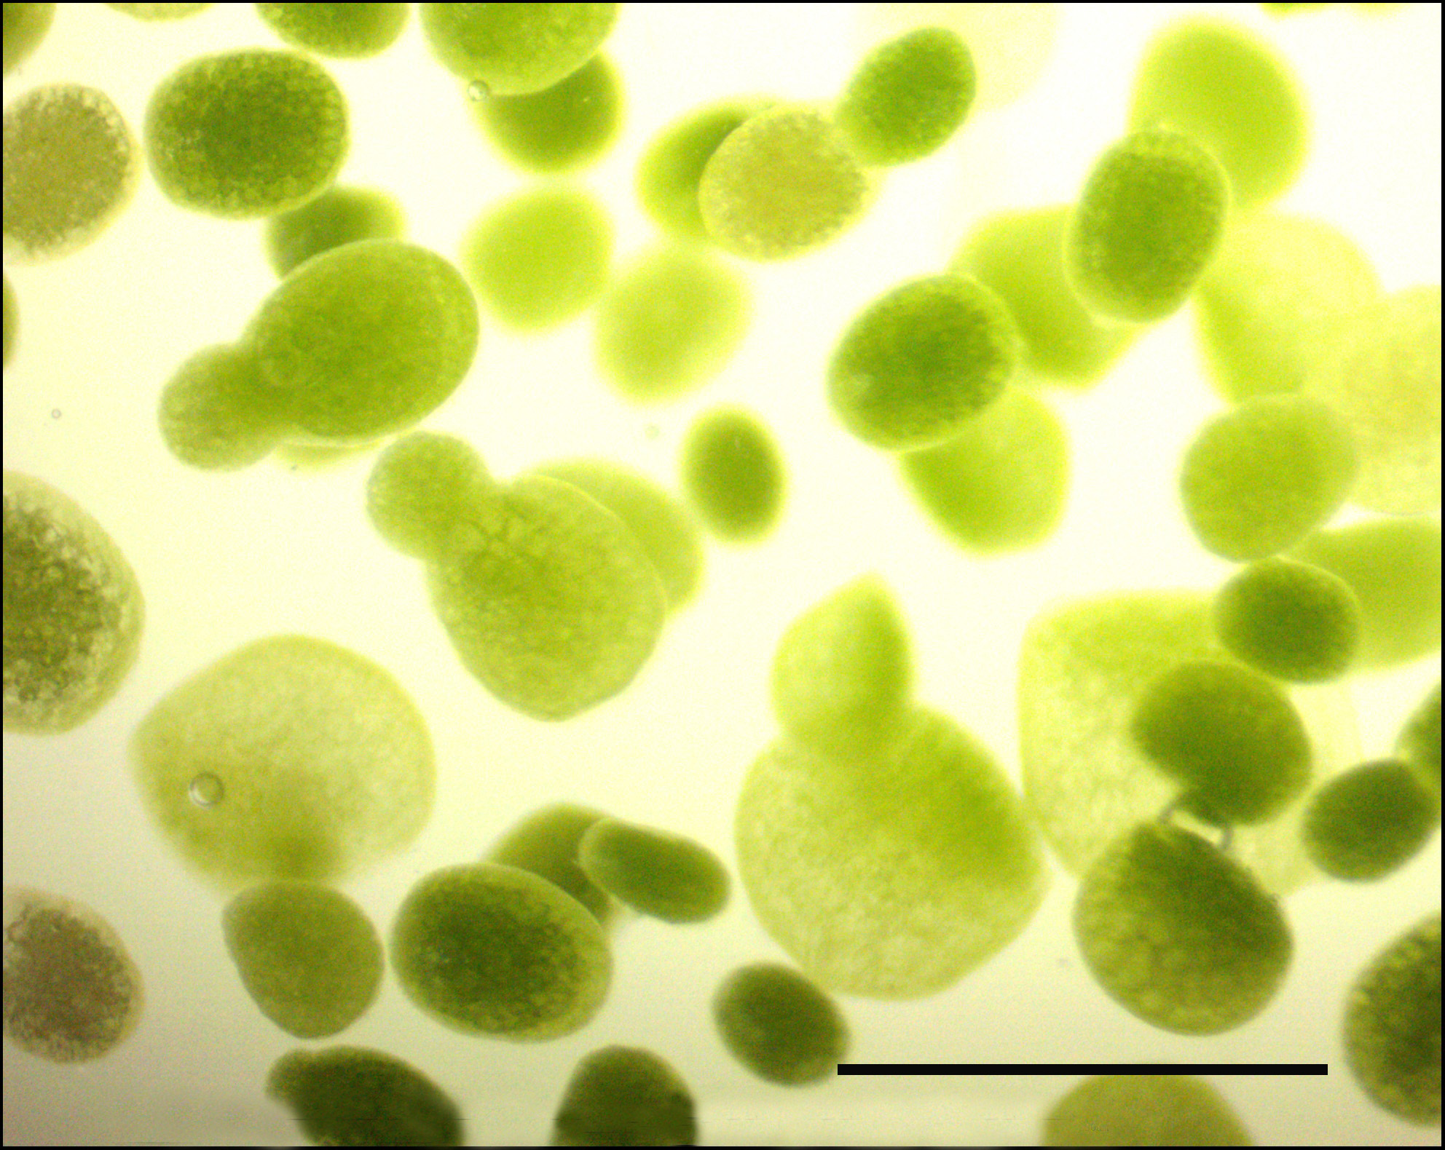

Scale Bar- 125µm

Molecular Classification:
atpF-atpH barcode:
Species | Alignment length(bp) | Mismatches/Gaps | Percent identity | Bit score | GenBank accession numbers for refence sequence
W. globosa | 631 | 0 | 100 | 1166 | KJ630544.1 KJ630535.1 KJ630520.1 KJ630517.1 KJ630515.1

Sequence:
ATTACTACGCTTAGATTTATTGGATTTGTTGCAAAAATATCGGTATTAAA
CCCAAAACCTCCGGCGGATGGCCAGTGGCCCAAGGAAACAAAAGAATCAG
TGACATTTATCATATACTCTCCTCTTATAGATAGGACTAACAAAGAACAG
AGTTCTTTTTGTATTACTCCCCCCCCCTTTGCTTTGATTGATTTCTTTTT
TTTTTTATGGGATTTTTGATTTTTATTTTAATCGATTAATTAATTTTAAT
TTAATTGAGAAACTTTTAATTGATTATTTTATAGAAAAAACAAATTAAAG
TTTACAATTACAAGAATCTACTTATTTTATTGGGTTAGGTCCTGGGTATT
TTGTCAATTGATAACTACCTTGTTTGTTGCGTTGCAACGCATACTAAAAA
AGGTTTCCATTAGACTACGAACTAAAAACGGGAAGGAAGAAAGCGAGAGG
ATCTGCTAATTACTAATCCTAAAATCAGTCCTTCCCGGAGGTATTCTATC
AACGAATAAGTAATTGTTATAGTGCAATTTAGAGATAATTCGAACAAGCA
AAAAGCAAGTCTAAGTCAAAAACACTATTACGTACTTTTTTATTCGAGAA
TTAAACAAATGGATTCGCAAATAAAAGTGCT

psbK-psbI barcode:

AFLP-Lemna Genotype:

AFLP-Wolffia Genotype:

Other Sequence:

Species Collection and Cultivation Information

Date:
September, 2014

Location:
(Provide information on site of collection. Include country, state/province, and city/town. Please be as specific as possible.)

Wolffia globosa was collected from pond in Wuhan Botanical Garden, Chinese Academy of Sciences (CAS) (30.54 º N and 114.42 º E) at the City of Wuhan, Hubei province, China.

Cultivation Information:
(Provide information on cultivation of clone since collection and how it is maintained. Mention if any genetic modifications or any other treatments have been performed on clone that may affect its natural physiology.)
After soaking in 0.1 % (W/V) mercuric chloride (HgCl₂) for 2-3 minutes and washing for 5 to 8 times using sterile deionized water, W. globosa collected was maintained in Petri-dishes containing solid Schenk and Hildebrand’s SH medium (Schenk and Hildebrandt, 1972) supplemented with 2 % (w/v) sucrose, 0.6 % (w/v) agar at pH 5.8 in dark for 3 days. Later Wolffia were cultured in incubator under 24 ± 2 ℃ at 85 μmol m⁻²s⁻¹ and a photoperiod of 16 h light and 8 h darkness. In every two weeks, regenerated fresh fronds were sub-cultured in fresh liquid or solid SH medium containing 2 % (w/v) sucrose, for longtime preservation. Furthermore, unsterilized W. globosa was directly cultured in water outdoor.

To which Duckweed collection are you able to submit your clone?
(One of the goals of the RDSC is to have its registered clones available to the community to promote research and applications.)
RDSC ✓
University Of Jena

