Contact Information
Name:
Metha Meetam
Contact Phone Number:
+66-83-1896660
Contact Email:
Metha.mee@mahidol.ac.th
Affiliation:
Department of Biology, Faculty of Science, Mahidol University, Bangkok, Thailand

Manuscript Information (if applicable)
Title:
The biological responses and metal phytoaccumulation of duckweed Spirodela polyrhiza to manganese and chromium
Journal:
Environmental Science and Pollution Research
Authors:
Ying Liu, Tanatcha Sanguanphun, Wenqiao Yuan, Jay J. Cheng, Metha Meetam

Species Identification Information
Name Of Species:
Spirodela polyrhiza
Morphological Classification (if applicable):

Molecular Classification:
atpF-atpH barcode:
Spirodela polyrhiza

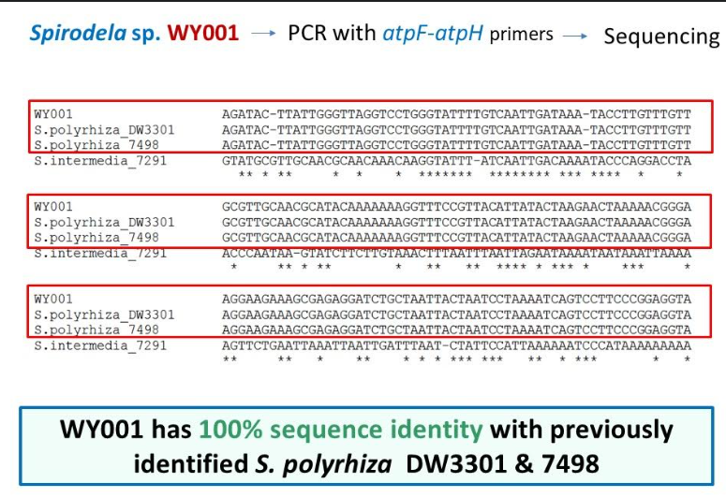

psbK-psbI barcode:

AFLP-Lemna Genotype:

AFLP-Wolffia Genotype:

Other Sequence:

Species Collection And Cultivation Information
Date:
September, 2016
Location:
(Provide information on site of collection. Include country, state/province, and city/town. Please be as specific as possible.)
Raleigh, North Carolina, USA
Cultivation Information:
(Provide information on cultivation of clone since collection and how it is maintained. Mention if any genetic modifications or any other treatments have been performed on clone that may affect its natural physiology.)
SH medium, no genetic modification

To which Duckweed collection are you able to submit your clone?
(One of the goals of the RDSC is to have its registered clones available to the community to promote research and applications.) If needed, I can to either or both places once the weather permits.
X RDSC
X University Of Jena

Cited in—
